

**Gulf Aluminium Rolling Mill B.S.C.**

CEA / MRE Management System

*User Manual*

Table of Contents

How to Submit a New CEA Request? 3

How to View the Approval Status of a Submitted Request? 8

How to View the Expenses of a CEA Request? 11

How to Cancel a CEA Request? 14

How to Print the CEA Report? 15

How to View the Detailed Expense Report? 17

How to View the Expense Report? 18

How to View the Requisition Report? 19

How to Upload an Approved CEA Requisition into JDE? 20

How to Close a CEA Requisition? 22

How to Upload New Projects from an Excel File? 23

How to Modify the Project Details? 25

How to Assign Equipment Number? 27

How to Reassign Requisition? 29

## How to Submit a New CEA Request?

1. Open the Project Inquiry page. Selec the Fiscal Year, Project Status, and Cost Center, and then click the **Search** button. Select the desired project from the grid and then click the **Create** button. A screenshot of a computer

   Description automatically generated
2. Provide data to the required fields in the “**Requisition Details**” tab.

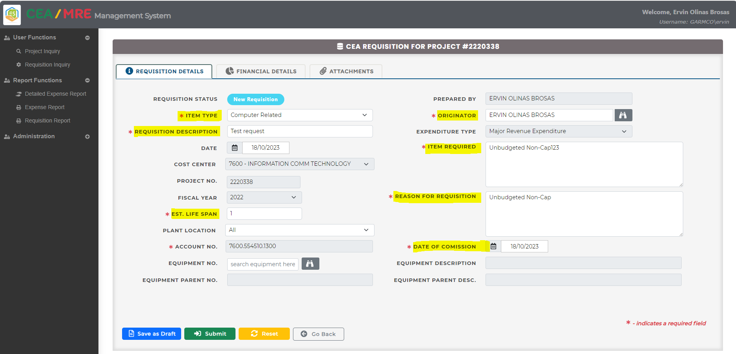

1. To add expense items, click the **Financial Details** tab and then follow the below procedures.
   1. Enter value for the **Estimated Cost** field. *(Notes: The sum of all items entered in the* ***Schedules of Expenses*** *section should be equal to whatever value specified in this field.)*
   2. Provide the expense items in the **Schedule of Expenses** section:
      * Select the **Fiscal Year**
      * Select which **Quarter**
      * Specify the **Amount**
      * Click the plus icon  to add the expense item into the grid. Repeat these steps for adding multiple expense items.

1. To add attachments, click the **Attachments** tab and then follow the below procedures.
   1. Click the plus icon  to open the pop-up form for selecting the desired file.

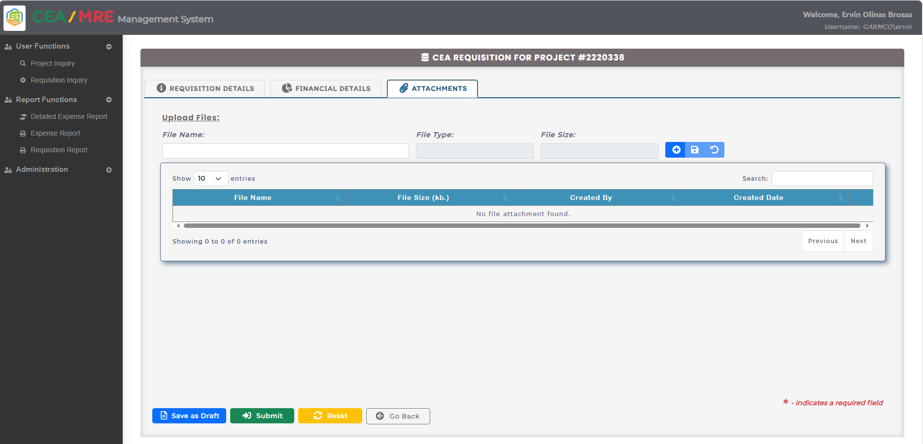

* 1. Browse the desired file, select it , and then click the **Open** button.

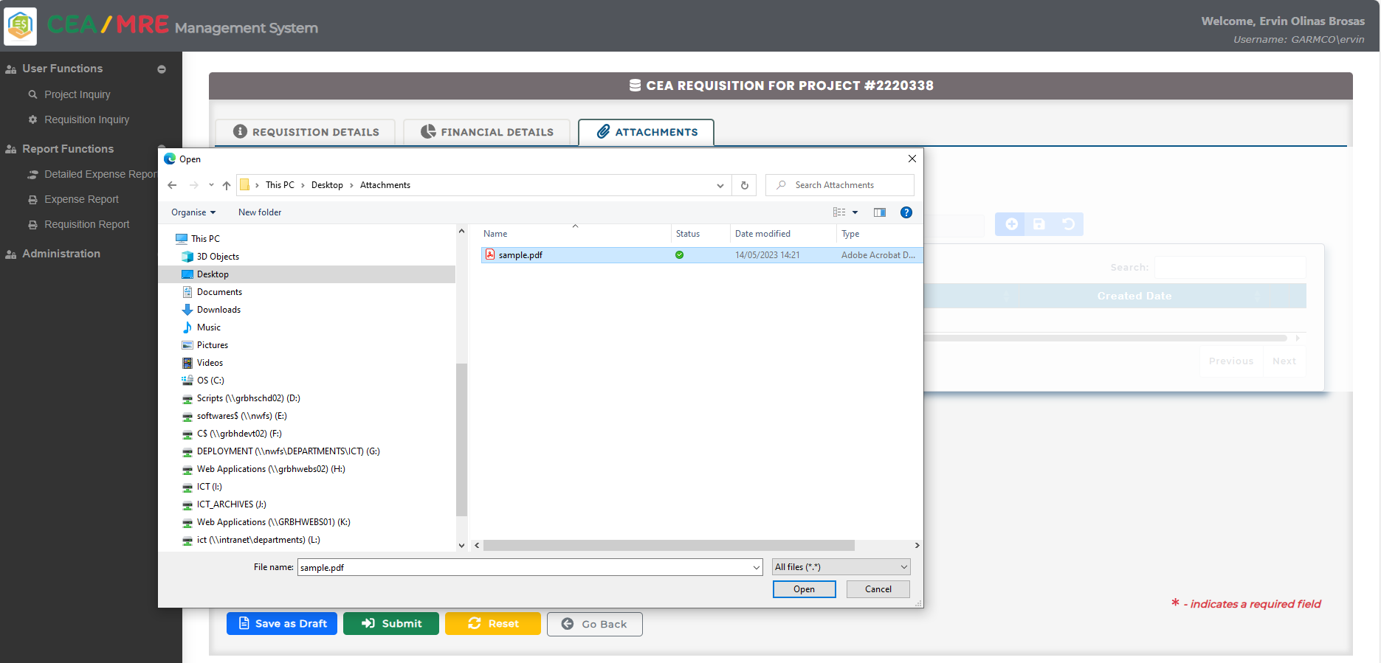

* 1. You can change the file name if needed, then click the save icon  to add the expense item into the grid.

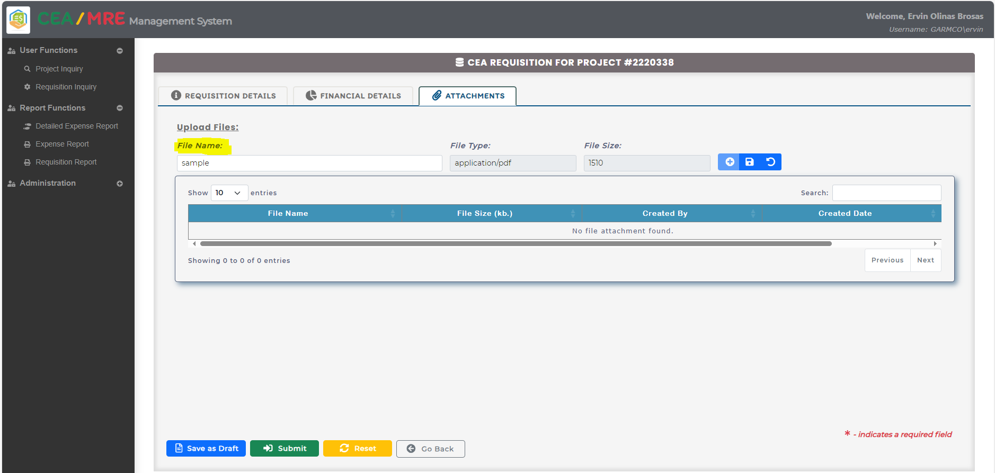

* 1. To view and download the attachment, click the download button  in the grid. To delete the attachment, click the delete button 

1. To finalize the CEA request and submit it, click the submit button  which can be found at the button of the form.

1. After submission, the Requisition Inquiry page will be displayed showing the current status of the request.

## How to View the Approval Status of a Submitted Request?

**Option #1:**

1. Click the **Requisition Inquiry** link from the navigation bar located at the right-hand side of the screen. Enter the **Requisition No.**, and then click the **Search** button. The basic information about the request will be shown on the grid, and to view the approval status history, click the **Status** field value on the grid. 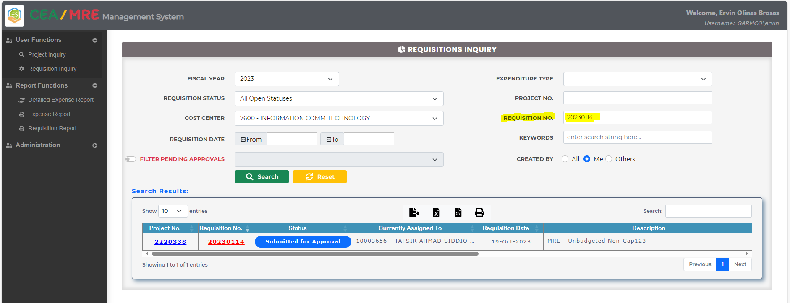
2. The **Requisition Status** page will be displayed on the screen showing the approval process flow, and the currently assigned person where the value of **Current Status** is “In-progress”.

**Option #2:**

1. Click the **Requisition Inquiry** link from the navigation bar located at the right-hand side of the screen. Enter the **Requisition No.**, and then click the **Search** button. Click the **Requisition No.** link on the grid. A screenshot of a computer

   Description automatically generated
2. From the CEA Requisition Details page, click the **Other Action** button and then click **View Approvers** link.

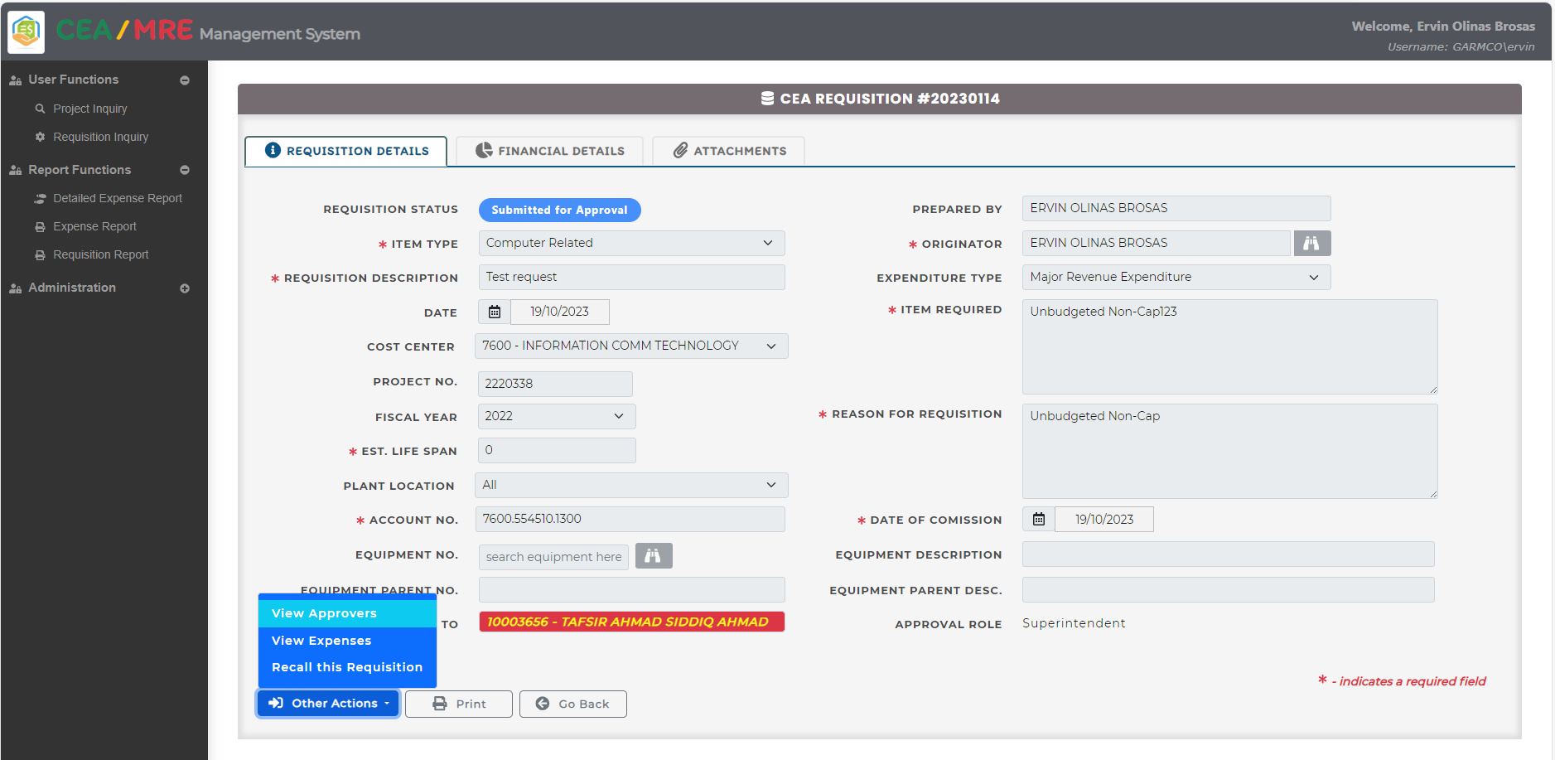

1. The **Requisition Status** page will be displayed on the screen showing the approval process flow, and the currently assigned person where the value of **Current Status** is “In-progress”.

## How to View the Expenses of a CEA Request?

**Option #1:**

1. Click the **Requisition Inquiry** link from the navigation bar located at the right-hand side of the screen. Enter the desired **Requisition No.**, and then click the **Search** button. In the search result grid, scroll to the right until the **View Expenses** button is shown. Click this button to open the **Expenses View** page.. A screenshot of a computer

   Description automatically generated
2. The **Expenses View** page will show all purchase order requisitions created for the CEA. To export data into Excel or CSV file format, click the corresponding icon in the grid’s toolbar. To print the report, click the print icon in the toolbar.

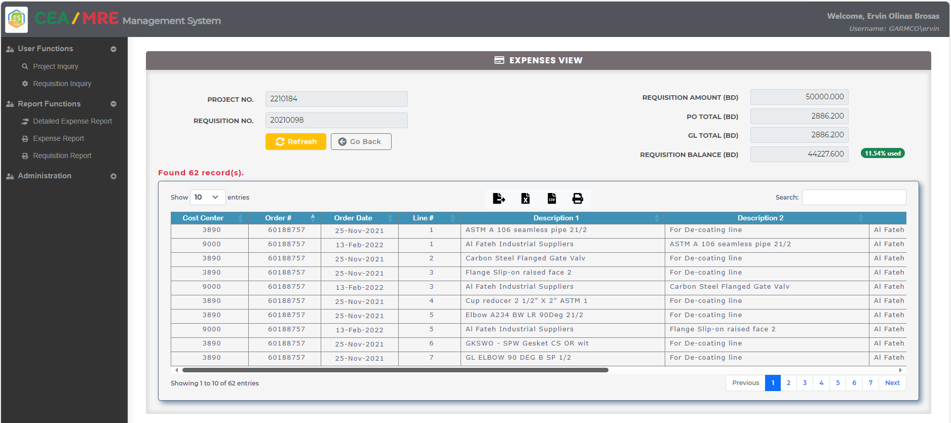

**Option #2:**

1. Click the **Requisition Inquiry** link from the navigation bar located at the right-hand side of the screen. Enter the **Requisition No.**, and then click the **Search** button. Click the **Requisition No.** link on the grid. 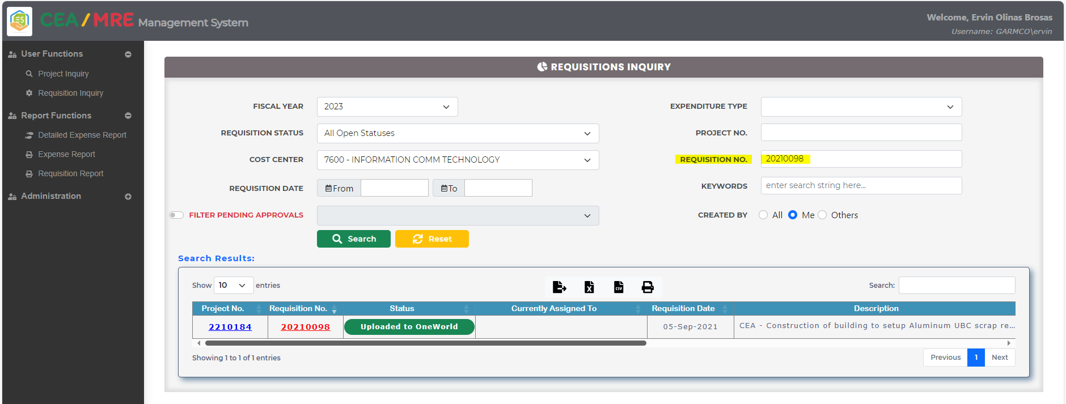
2. From the CEA Requisition Details page, click the **Other Action** button and then click **View Expenses** link.

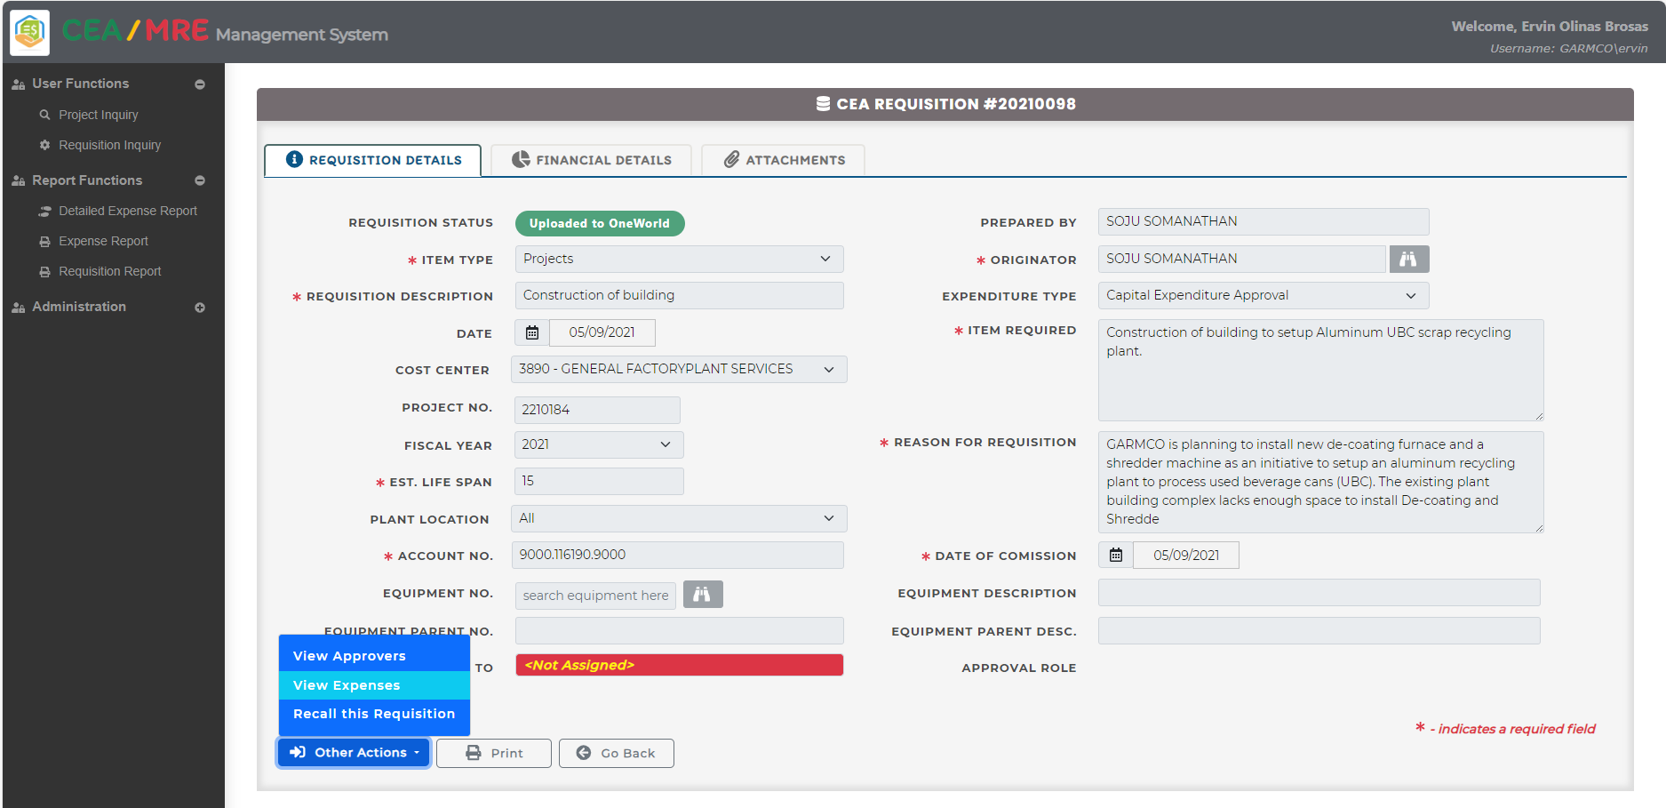

1. The **Expenses View** page will show all purchase order requisitions created for the CEA. To export data into Excel or CSV file format, click the corresponding icon in the grid’s toolbar. To print the report, click the print icon in the toolbar.



## How to Cancel a CEA Request?

1. Click the **Requisition Inquiry** link from the navigation bar located at the right-hand side of the screen. Enter the **Requisition No.**, and then click the **Search** button. Click the **Requisition No.** link on the grid. 
2. From the CEA Requisition Details page, click the **Other Action** button and then click the **Recall this Requisition** link.

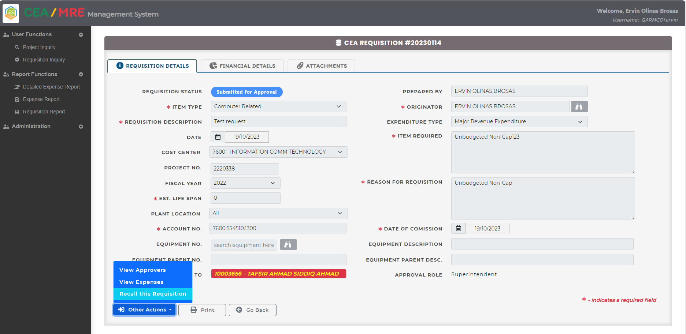

1. The **Recall Requisition** pop-up form will appear on the screen. Provide the **Justification**, and then click the **Submit** button.

## How to Print the CEA Report?

1. Click the **Requisition Inquiry** link from the navigation bar located at the right-hand side of the screen. Enter the desired **Requisition No.**, and then click the **Search** button. Click the **Requisition No.** link on the grid. 
2. Click the **Print** button.

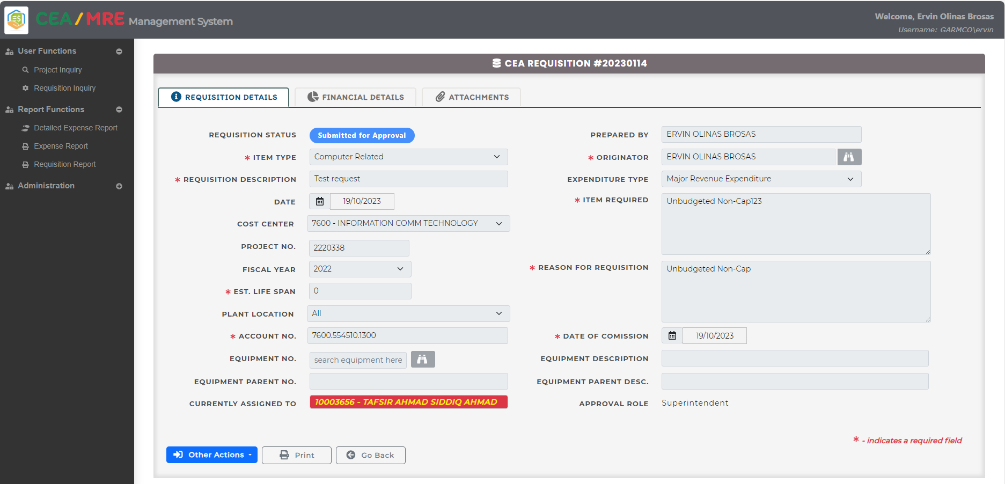

1. The report will be shown on the screen. Click the print toolbar icon to send the document to the printer, or click the save button to save a copy of the document, in PDF format, to the local file system.

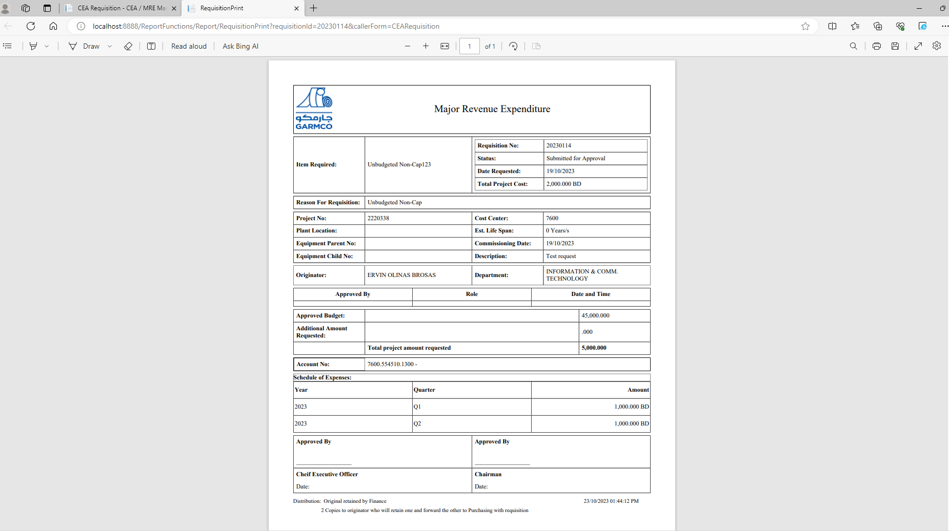

## How to View the Detailed Expense Report?

1. Click the **Detailed Expense Report** link from the navigation bar located at the right-hand side of the screen. Fill in the search filter criteria to fine tune the result, and then click the **Search** button.

1. Click the Excel toolbar icon to export the data displayed on the grid into an Excel file format.

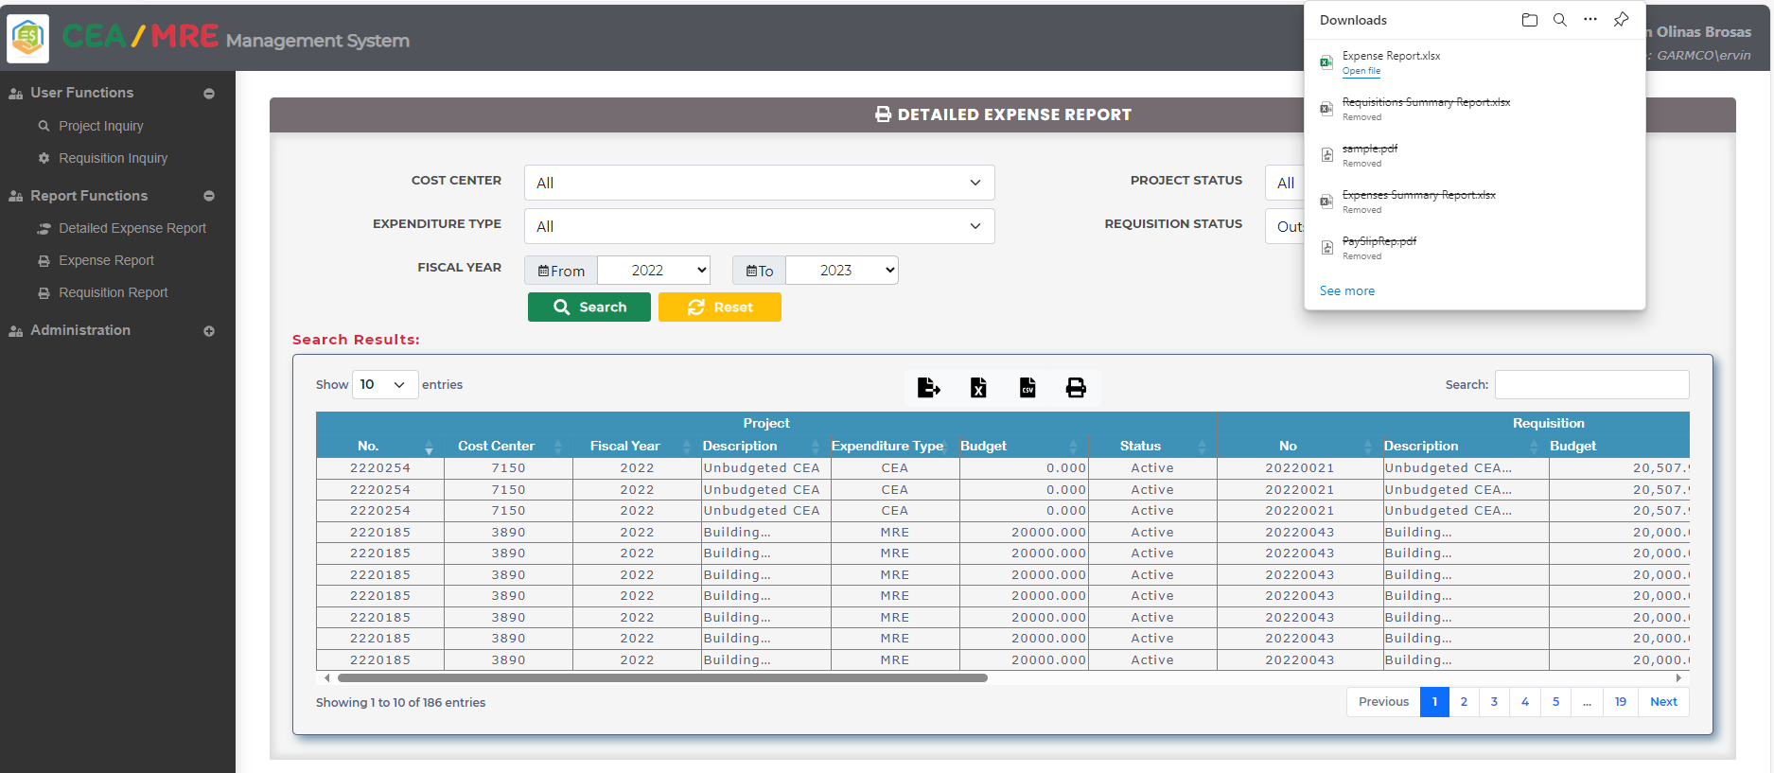

## How to View the Expense Report?

1. Click the **Expense Report** link from the navigation bar located at the right-hand side of the screen. Fill in the search filter criteria to fine tune the result, and then click the **Search** button. A screenshot of a computer

   Description automatically generated
2. Click the Excel toolbar icon to export the data displayed on the grid into an Excel file format.

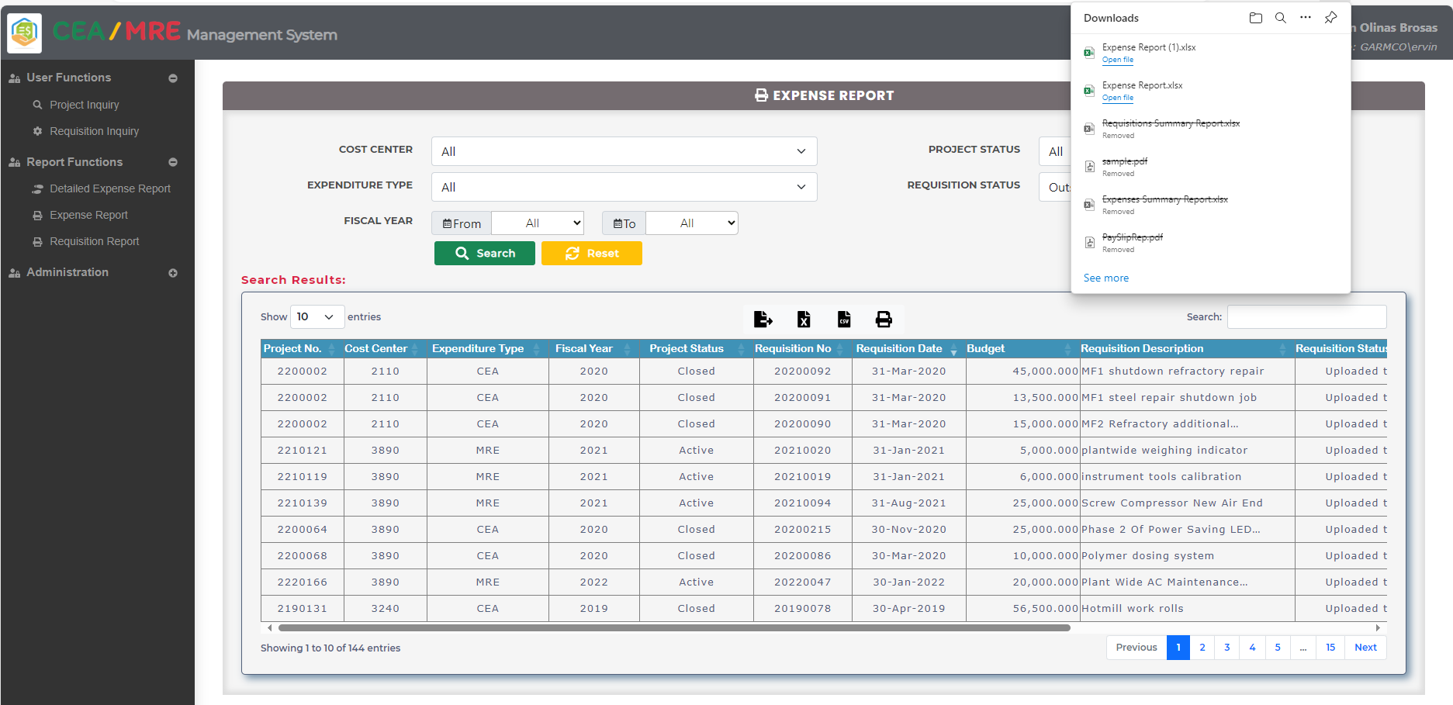

## How to View the Requisition Report?

1. Click the **Expense Report** link from the navigation bar located at the right-hand side of the screen. Fill in the search filter criteria to fine tune the result, and then click the **Search** button. A screenshot of a computer

   Description automatically generated
2. Click the Excel toolbar icon to export the data displayed on the grid into an Excel file format.

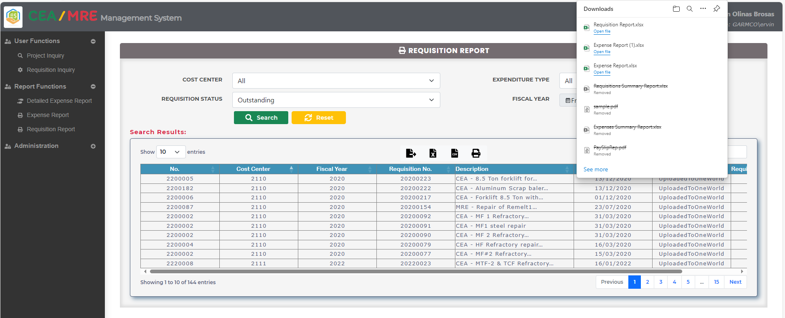

## How to Upload an Approved CEA Requisition into JDE?

*Note that the access for posting an approved CEA request into JDE is granted only to authorized personnel that include the Exec. Personal Assistant role as well as some ICT Administrators. No other users have access to this feature, hence, this form is locked when opened by an unauthorized user.*

1. A screenshot of a computer program

   Description automatically generatedClick the **Requisition Administration** link from the navigation bar located at the right-hand side of the screen. Enter the desired **Requisition No.**, and then click the **Search** button. Click the **Upload to OneWorld** button on the grid to post the CEA request into JDE system. 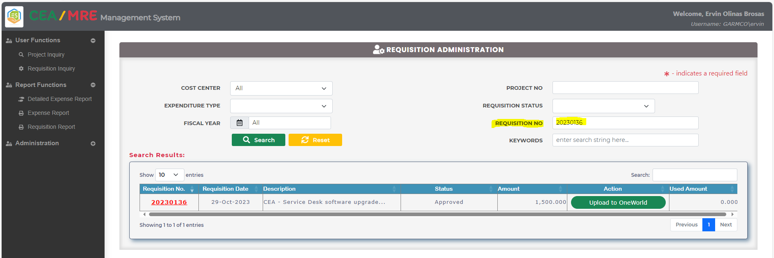
2. A system notification about the successful posting to JDE will be sent to the Originator cc copy to the request creator, as well as to all persons who have approved the request.

1. Once posted to JDE, the request status will change to **Uploaded to OneWorld**, and the **Close Requisition** action button will be shown on the grid. This button will be used to close the CEA request.

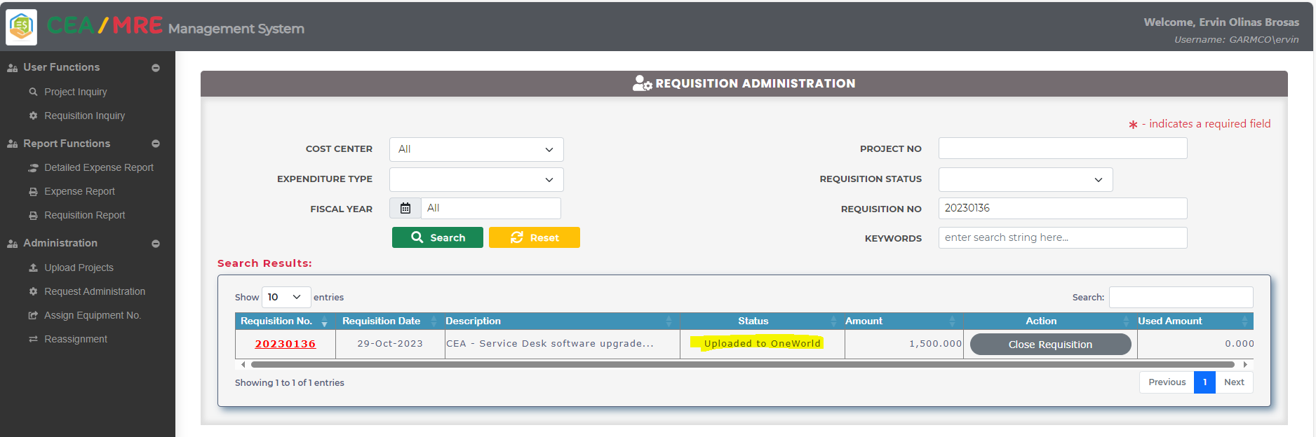

## How to Close a CEA Requisition?

*Note that the access for closing a CEA requisition is granted only to authorized personnel that include the Exec. Personal Assistant role as well as some ICT Administrators. No other users have access to this feature, hence, this form is locked when opened by an unauthorized user.*

1. Click the **Requisition Administration** link from the navigation bar located at the right-hand side of the screen. Enter the desired **Requisition No.**, and then click the **Search** button. Click the **Upload to OneWorld** button on the grid to post the CEA request into JDE system. A screenshot of a computer

   Description automatically generated
2. Click the **Close Requisition** button in the grid to set the CEA requisition into closed status. Note that an email notification will be sent to the request creator cc copy to the Originator and all persons who have approved the request.

## How to Upload New Projects from an Excel File?

*Note that the access for uploading new projects into the system is given only to selected users from the Finance department, so no other users can use this feature. Below summarizes the step-by-step procedures on how to upload new projects from an external Excel file.*

1. Expand the **Administration** menu item and then click **Upload Projects** link. Click the **Choose File** buttonto select and upload the desired Excel file.

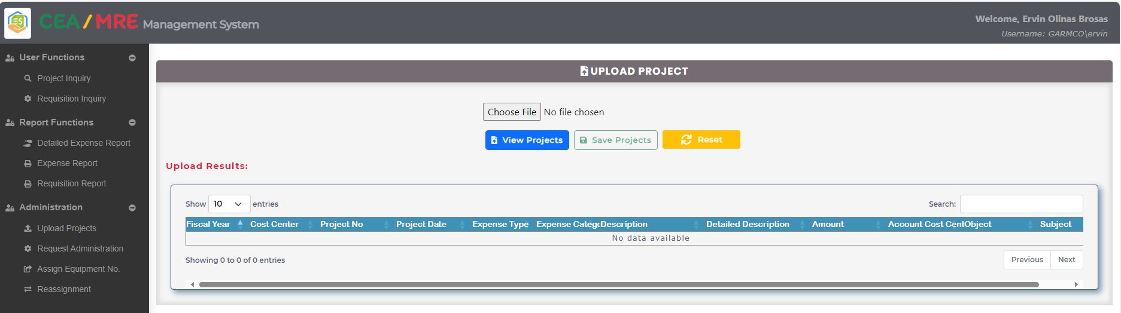

1. Locate the Excel file that contains the list of all projects with budget information. Select the desired file and then click the Open buton.

1. Click the **View Projects** button to show in the grid the list of all projects contained in the selected Excel file, which need to be uploaded in the system.

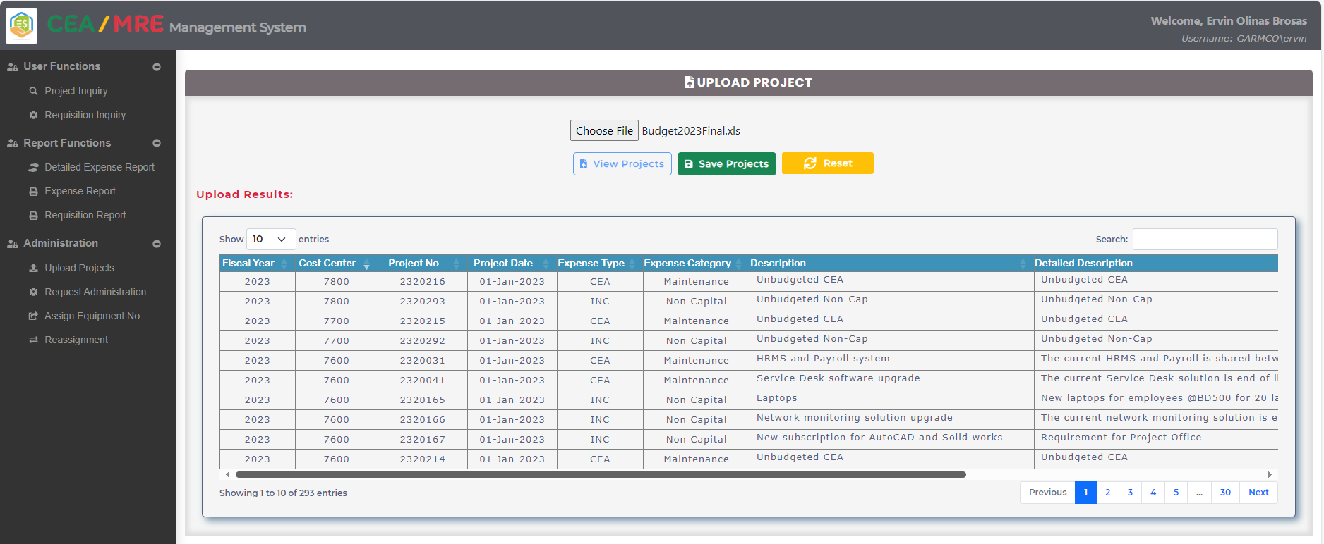

1. Verify the information displayed on the grid, and then click the **Save Projects** button to initiate the upload process. If data is uploaded successfully, a notification alert will be shown at the top-right corner of the screen. In the same manner, data in the grid will be cleared out.

1. To check and verify the uploaded projects, go to the Project Inquiry page and then specify the search filters.

## How to Modify the Project Details?

*Note that only authorized employees from the Finance department have access to this functionality, hence, this form is locked when opened by an unauthorized user.*

1. Click the **Project Inquiry** link from the navigation bar located at the right-hand side of the screen. Select the desired project to edit from the grid, and then click the **Project No.** link. Take note that only authorized person can modify the project details, which is usually given to Finance team since they are the ones who manage the project budget.A screenshot of a computer

   Description automatically generated
2. Click the **Edit** button to modify the project details such as Budget Year, Expenditure Type, Expected Project Date, Description, Detailed Description, Cost Center, and Budgeted Project Amount. Click the **Save** button to commit changes to the database.

1. A toast message will be shown at the top-right corner of the screen confirming the successful data update process.

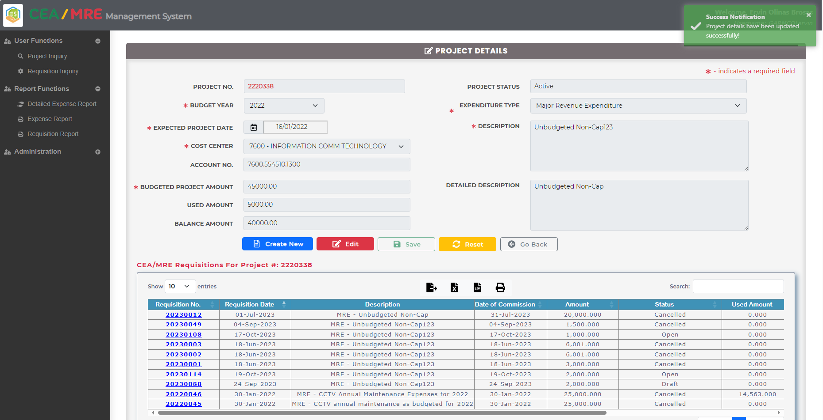

## How to Assign Equipment Number?

*To assign an equipment number to a CEA requisition, the request status should be in any of the following: ‘Approved’, ‘ChairmanApproved’, and ‘UploadToOneWorld’. When an equipment number was already assigned to a CEA requisition, it will not be listed in the search result grid. Below summarizes the step-by-step procedures on how to assign the equipment number to the requisition.*

1. Click the **Assign Equiment No.** link from the navigation bar located at the left-hand side of the screen. Choose the desired requisition, and then click the **Select** button  from the grid.

1. Click the **Select** button to show the “**Equipments Number**” pop-up form. Choose the desired equipment listed in the grid, and then click the **Select**  button .

1. The details of the selected equipment will be displayed on the form. To commit the changes to the database, click the **Save** button.

1. A notificationmessage will be shown at the top-right corner of the screen to inform users about the successful operation.

## How to Reassign Requisition?

*Note that to reassign the requisition, the requisitions should be in the status of 'Submitted for Approval' or 'Awaiting Chairman Approval'.*

1. Click the **Assign Equiment No** link from the navigation bar located at the right-hand side of the screen. Select the desired requisition number to assign the equipment number from the grid.

1. The search requisition should be in the status of 'Submitted for Approval' or 'Awaiting Chairman Approval' otherwise it will raise an error.

1. Click the **checkbox** in the search result for the reassign the requisition, choose the name for new approver and add the reason to the Remarks.

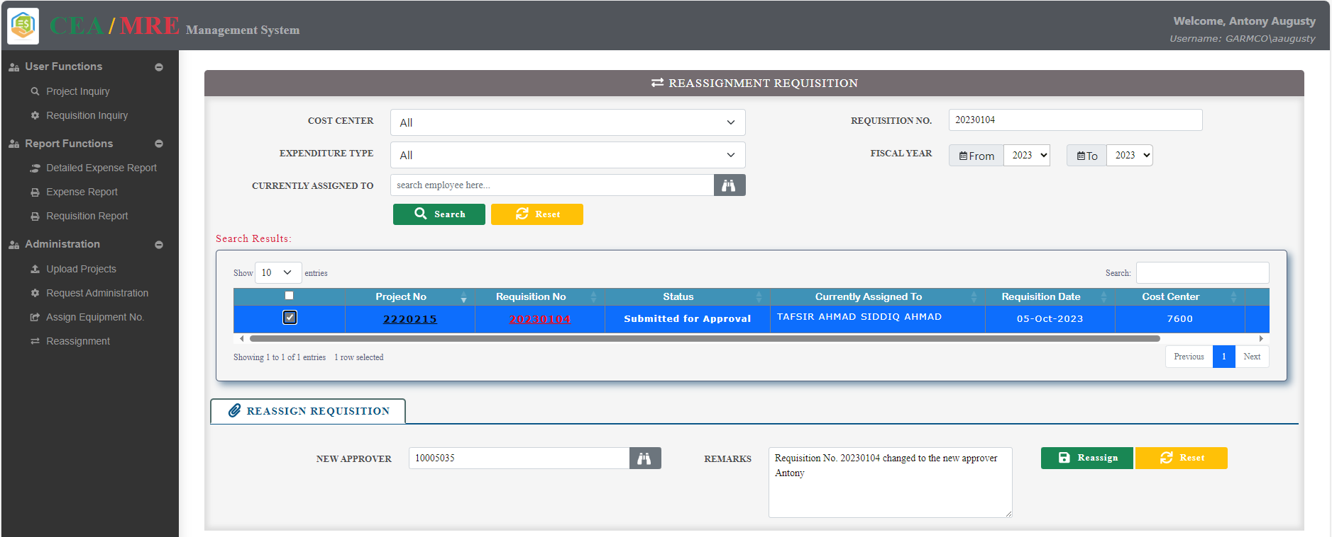

1. Click the **Save** button to commit changes to the database. A toast message will be shown at the top-right corner of the screen confirming the successful data update process.

1. To check and verify the Reassigned Approver , go to the Requisition Inquiry page and click on the requisition number.

